Test Project Day 2
  - Graphic Design Technology

Introduction to Test Project

Contents
- WSC2019_TP40_Day2.docx (this file)
- Appendix 1.0 – Logo
supplied on competitor desktop in folder called: WSC2019_TP40_Day2_CompetitorFiles
- Appendix 1.1 – Package Text
supplied on competitor desktop in folder called: WSC2019_TP40_Day2_CompetitorFiles
- Appendix 1.2 – Images
supplied on competitor desktop in folder called: WSC2019_TP40_Day2_CompetitorFiles
- Appendix 1.3 – Barcode
supplied on competitor desktop in folder called: WSC2019_TP40_Day2_CompetitorFiles
- Appendix 1.4 - Label Text
supplied on competitor desktop in folder called: WSC2019_TP40_Day2_CompetitorFiles

Introduction
Mongolia is one of the few countries that officially supports traditional medicine.
In 1330, a Mongolian physician published a book called Important Principles of Food and Drink. It was the first book of its kind. He discussed the importance of a balanced diet with a focus on moderation.
Self Created is a Mongolian company that makes traditional medicine. The ingredients used are a range of modern herbs and ones that have been used for hundreds (and thousands) of years.
They believe in the power of combining scientific research with history.
Their logo symbol is the Soyombo (meaning: self created), which is also the symbol of Mongolia and appears on the country's flag.

Description of project and tasks
Mongolia's capital city of Ulaanbaatar has the second highest fine particle pollution of any city in the world.
Poor air quality is also the largest occupational hazard, as over two-thirds of occupational disease in Mongolia is dust induced chronic bronchitis or pneumoconiosis.
Self Created are launching a medicinal liquid product called Breathe Easy which has been created to help cure these diseases.
The most important ingredients are three herbs:
- Pasque Flower (Pulsatilla ambigua)
- Common Nettle (Urtica dioica)
- Thyme (Thymus vulgaris)
Self Created are also launching this product throughout Asia and will include English and Chinese text on their designs.
Ease of use considered should be considered when designing the products for the demographic. They also want to use a cool colour palette.

Demographics:
- Gender: Male (90%) and Female (10%)
- Age: 55+ years old
- Location: Asia
- Income: low (100%)
- Other: have worked in highly polluted areas for an extended period of time (most of their life), likely to be trades people (working in harsh outside conditions).

Tasks:
- Package design
- Label design for 100ml brown glass bottle (to go inside the package)

Instructions to the Competitor
Create a folder on your desktop called YY_TESTPROJECT_DAY2 (where YY represents the number of your workstation). All final and packaged files must be included in this folder.
You must include your workstation number on the presentation board and printouts for marking and delivery to your workstation (the number should be outside of the artwork).
This folder structure will be as follows:
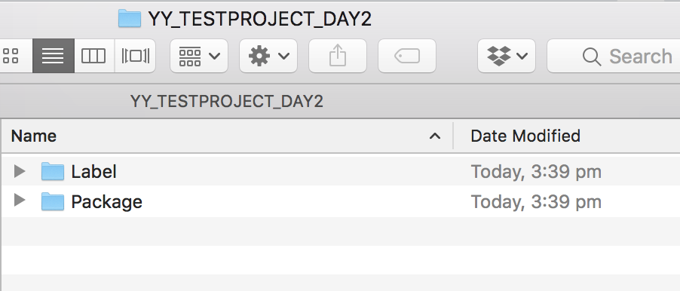

Task 1: Package

Concept
The package shape and design is up to you. It must be able to fit a 100ml brown glass bottle inside.

Specifications
Type and Image
The package must include the following:
- Logo in Appendix 1.0 – Logo (you may change the colour of the logo)
- All text from Appendix 1.1 – Package Text
- You can choose if you want to use any images from Appendix 1.2 – Images (not mandatory)
- Barcode in 100% black at a minimum of 30mm wide from Appendix 1.3 – Barcode
Size
- Maximum 420x297mm (including bleed)

Dieline
- 0.5pt
- Separate layer called: Cut lines
- Spot colour for cut lines called: Cut lines (any colour)
- Separate layer called: Fold lines
- Spot colour for fold lines called: Fold lines (any colour)
- Separate layer called: Glue dots
- Spot colour for glue dots lines called: Glue dots (any colour, indicated by dots, not lines)
Colour
- CMYK + 2 x PMS C colours
Bleed
- 2.5mm (exactly)
File Type
- • Package: AI or INDD — without outlined text
- • Package: PDF/X-4:2008 — without outlined text
- • Raster images: .tiff, .psd, .dsc, .eps
- • Vector images: .ai, .eps
Resolution
- Raster images: 350dpi (placed at 100% in Illustrator or InDesign)
Naming:
Note: YY represents your competitor number
Folder name: Package
- Package file name:
YY_Self_Created_Package.ai
OR
YY_Self_Created_Package.indd
- Package file name: YY_Self_Created_Package.pdf
You must deliver
Prints
- 1 x colour mock up, folded and stuck together at actual size (100%), printed on SRA3 card stock.
- 1 x colour printout, reduced to fit on A3 with bleed, dieline, colour bars and registration marks. Ensure that you include your competitor number of the front, outside the artwork area.
Files
- 1 x PDF file with bleed, dieline, colour bars and registration marks
- 1 x INDD file or 1 x AI file
- You must include a packaged Adobe InDesign or Illustrator folder for submission that includes all fonts and links used.
- You may include any working files in a separate folder called: Working files

Task 2: Label

Concept
The label shape and design is up to you.
It must be able to fit on a 100ml brown glass bottle and inside the package you have designed.

Specifications
Type and Image
The label must include the following:
- Logo in Appendix 1.0 – Logo (you may change the colour of the logo)
- All text from Appendix 1.4 – Label Text
- You can choose if you want to use any images from Appendix 1.2 – Images (not mandatory)
Size
- Maximum 148x105mm (including bleed)
Dieline
- 0.50pt
- Spot colour called: Dieline
- Separate layer called: Dieline
- Cuts only
Colour
- CMYK + 2 x PMS C colours
Bleed
- 3.0mm (exactly)
File Type
- Label: AI or INDD — without outlined text
- Label: PDF/X-4:2008 — without outlined text
- Raster images: .tiff, .psd, .dsc, .eps
- Vector images: .ai, .eps
Resolution
- Raster images: 400dpi (placed at 100% in Illustrator or InDesign)
Naming:
Note: YY represents your competitor number
Folder name: Label
- Package file name:
YY_Self_Created_Label.ai
OR
YY_Self_Created_Label.indd
- Package file name: YY_Self_Created_Label.pdf

You must deliver
Mounting and Prints
- 1 x colour print of the label at 100% (actual size) with bleed, dieline, colour bars and registration marks. Mounted on A4 board. Ensure that you include your competitor number on the front of the board, outside of the design area.
- 1 x colour print, trimmed to 100% (actual size). Printed on label stock.
Files
- 1 x PDF file with bleed, dieline, colour bars and registration marks
- 1 x INDD file or 1 x AI file
- You must include a packaged Adobe InDesign or Illustrator folder for submission that includes all fonts and links used.
- You may include any working files in a separate folder called: Working files

Marking Summary
The Marking Summary will be either provided during the briefing session on C2 or at your workstation.

Appendix 1.1 Package Text
Note: Text to be included in package is Blue in colour
The black text is not to be included (they are instructions)
The package must include the following text:
Breathe Easy
Traditional medicine
With Pasque Flower, Thyme and Common Nettle
100ml
To help cure diseases related to polluted air
Self Created — combining scientific research with history
放轻松
传统药物
与Pasque花，百里香和共同的荨麻
100毫升
帮助治疗与污染空气有关的疾病
自创 - 将科学研究与历史相结合
Instructions
6–12 years
5ml
2 x per day
12+ years
10ml
2 x times per day
Do not exceed the recommended dosage.
Do not use in children under 6 years of age
说明
6-12岁
5毫升
每天2 x
12年以上
10毫升
每天2次
不要超过推荐剂量。
不要在6岁以下的儿童使用
Ingredients
Each 10ml of oral liquid contains:
Active Ingredients: Pasque Flower (Pulsatilla ambigua) 800mg, Common Nettle (Urtica dioica) 300mg, • Thyme (Thymus vulgaris) 200mg, Dextromethorphan Hydrobromide monohydrate 30mg
Also contains Sodium benzoate, Saccharin sodium, Glucose (from wheat), Fructose, Maltose and Alcohol (1.5%).
配料
每10ml口服液含有：
有效成分：白头翁（Pulsatilla ambigua）800mg，普通荨麻（异荨麻）300mg，•百里香（Thymus vulgaris）200mg，氢溴酸右美沙芬一水合物30mg
还含有苯甲酸钠，糖精钠，葡萄糖（来自小麦），果糖，麦芽糖和酒精（1.5％）。
Use within six months of opening
在开业后六个月内使用

Appendix 1.3 Label Text
Note: Text to be included in label is Blue in colour
The black text is not to be included (they are instructions)
The label must include the following text:
Breathe Easy
Traditional medicine
With Pasque Flower, Thyme and Common Nettle
100ml
To help cure diseases related to polluted air
Self Created — combining scientific research with history
放轻松
传统药物
与Pasque花，百里香和共同的荨麻
100毫升
帮助治疗与污染空气有关的疾病
自创 - 将科学研究与历史相结合
Refer to box for instructions and ingredients
有关说明和成分，请参阅框

